The Islamia University of Bahawalpur
Department of Information Technology
Faculty of Computing



Software Requirement Specification (SRS)
for

Online Apportionment Booking System

Version 1.0

By
Fatima Javed
S25BINFT7M04027
Session Spring 2025 – 2027
Supervisor
Dr Mustafa Hameed
Bachelor of Science in Information Technology

Revision History

Name | Date | Reason for changes | Version

Document Approval
The following Software Requirements Specification has been accepted and approved by the following:
Signature | Printed Name | Title | Date

Application Evaluation History

Comments (by committee)  *include the ones given at scope time both in doc and presentation | Action Taken

Supervised by
Dr Mustafa Hameed
Signature

Table of Contents

1. Introduction 1
1.1 Purpose 1
1.2 Scope 1
1.3 Definitions, Acronyms, and Abbreviations. 1
1.4 References 1
1.5 Overview 1
2. The Overall Description 2
2.1 Product Perspective 2
2.1.1 Operations 2
2.1.2 Site Adaptation Requirements 3
2.2 Product Functions 3
2.3 User Characteristics 3
2.4 General Constraints 4
2.5 Assumptions and Dependencies 4
3. Specific Requirements 4
3.1 External Interface Requirements 5
3.1.1 System Interfaces 5
3.1.2 Interfaces 5
3.1.3 Hardware Interfaces 5
3.1.4 Software Interfaces 5
3.1.5 Communications Interfaces 6
3.2 Functional Requirements 6
3.2.1 <Functional Requirement or Feature #1> 6
3.2.2 <Functional Requirement or Feature #2> 7
3.3 Use Cases 7
3.3.1 Use Case #1 7
3.3.2 Use Case #2 7
3.4 Classes / Objects 7
3.4.1 <Class / Object #1> 7
3.4.2 <Class / Object #2> 7
3.5 Non-Functional Requirements 7
3.5.1 Performance 8
3.5.2 Reliability 8
3.5.3 Availability 8
3.5.4 Security 8
3.5.5 Maintainability 8
3.5.6 Portability 8
3.6 Inverse Requirements 8
3.7 Logical Database Requirements 8
3.8 Design Constraints 8
3.8.1 Standards Compliance 8
4. Analysis Models 9
4.1 Sequence Diagrams 9
4.2 Data Flow Diagrams (DFD) 9
4.3 State-Transition Diagrams (STD) 9
5. Supporting Information 9
Appendix A – Background Research on: 9
Appendix B – Data Dictionary 9

Introduction
The Online Appointment Booking System helps both customers and providers to make the booking of appointments as easy as possible. Booking is still carried out manually in a lot of places and this can result in long queues, hassle and inefficient management of the service given to customers. The Online Appointment Booking System helps to eradicate all of these issues by enabling customers to make online bookings from anywhere. It also reduces queuing and makes a better use of time for companies and firms. All bookings are therefore registered and controlled in an optimal manner. With the Online Appointment Booking System customers and administrators save time and avoid all delays.

1.1 Purpose
This project is intended to facilitate an easy means through which appointments can be done online. It makes work easier and reduces human errors in scheduling. In so many organisations appointments have to be scheduled on phone which can take so much time and can also result in human errors. The online appointment system provides customers with an easy means of booking an appointment through an user friendly interface. On the side of the Administrator, the online appointment system helps him to keep track of all the bookings made for him in one place. It also helps in effective time management and booking appointment for two customers at a time which was largely prevalent. This project is also intended to increase customers’ satisfaction through timely and reliable service. It helps in keeping record of the customers’ appointments which may later be needed.

1.2 Scope
The Online Appointment Booking System application aim to provide the features and activities to carry out online appointments management efficiently. This system will allow customers to book appointments online at any time from any place. Thus no longer required to physically present themselves at any place of business. This system will make efficient use of available appointment slots and will hence minimize conflicts in the appointment slots.
It also allows the administration or service provider to see, confirm, reschedule or cancel an appointment. The system records all appointments and bookings, enabling better tracking, reporting and ultimately improved service quality. It also helps in better resource planning and utilization, thus helping in managing time and resources more effectively by reducing idle time and overcrowding.

Could add in for notifications, reminders and links to other systems. The system is aimed at businesses such as, clinics, salons, offices and service centres to name a few and the main goal is to run a business that is professional, efficient and customer satisfaction is improved through a well structured and automated online booking system.

1.3 Definitions, Acronyms, and Abbreviations.
Term / Acronym | Full Form / Definition
SRS | Software Requirements Specification; a document that describes the functionality, features, and constraints of the Online Appointment Booking System.
Online Appointment Booking System | A web-based application that allows users to schedule, manage, and track appointments with service providers online.
PHP | Hypertext Preprocessor; a server-side scripting language used to develop the Online Appointment Booking System.
Web Application | A software application that runs on a web server and is accessed through a web browser for booking and managing appointments.
Appointment Scheduling | The process of selecting and reserving a specific date and time slot for a service through the system.
User Management | The process of creating, updating, and maintaining user accounts, including customers and administrators.
Booking Management | The functionality that allows users to create, update, cancel, and view their appointments.
Notification System | A feature that sends alerts or reminders to users regarding their appointments via email or SMS.
Customer | A user who accesses the system to book, view, or manage their appointments.
Admin | An authorized user responsible for managing appointments, users, schedules, and system settings.
Time Slot | A specific period available for booking an appointment.
Dashboard | A web interface that displays summarized information such as bookings, schedules, and system status.
Database | A structured collection of data used to store user information, appointment details, and system records.
Authentication | The process of verifying the identity of users before granting access to the system.
Authorization | The process of granting users permission to access specific features based on their roles.
Performance | The ability of the system to handle multiple bookings efficiently and respond within acceptable time limits.
Security | Measures implemented to protect user data and prevent unauthorized access to the system.

1.4 References
No. | Document Title | Report No. / Version | Date | Publishing Organization | Source
1 | IEEE Standard for Software Requirements Specification | IEEE 830-1998 | 1998 | IEEE | https://standards.ieee.org
2 | ISO/IEC/IEEE Systems and Software Engineering — Life Cycle Processes | ISO/IEC/IEEE 12207 | 2017 | ISO / IEEE | https://www.iso.org
3 | PHP Official Documentation | PHP 8.x | Latest | PHP Group | https://www.php.net/docs.php
4 | MySQL Database Documentation | MySQL 8.x | Latest | Oracle Corporation | https://dev.mysql.com/doc/
5 | HTML Living Standard | HTML5 | Latest | WHATWG | https://html.spec.whatwg.org
6 | CSS Specifications | CSS3 | Latest | W3C | https://www.w3.org/Style/CSS/
7 | Online Appointment System Design References | N/A | 2026 | Various Authors | https://www.w3schools.com

1.5 Overview
Our Online Appointment Booking System simplifies the process of booking, managing and tracking appointments, for both customers and service providers. The Online Appointment Booking System removes the hassle of physical queues and promotes a faster way of dealing with customers and clients, taking the pressure off, saving time and reducing stresses. With a simple web based interface, up to date availability, email or SMS notifications and comprehensive controls for administration, the system is designed to aid service providers in delivering improved services, whilst increasing customer satisfaction and maximising utilisation of time.

2. The Overall Description
This section is an overview of the online appointment booking system and its general characteristics and functions. Our system combines a number of functions such as User Management, Appointment Booking, Reminders and Administrative Tools like Blocking of Time Slots and Statistics. It has a fully accessible web based interface, user friendly login management and a variety of features for storing and handling data in real time. The system is multi user and suitable for a large number of users and devices. It offers customers and administrators full flexibility, while the system remains stable and data is always secure.

2.1 Product Perspective
Our Online Appointment Booking System is a standalone software solution for organizations that requires minimal setup and configuration. Developed as a full web-based solution, it enables online booking of appointments via the organization’s own website while being a fully independent system. Appointments, users, services and more are stored in a central database and the system can even send information to external services in the form of emails or SMS notifications. Because the system has been developed to be highly scalable, expandable and maintainable, it’s easy to add new functionality and report systems at a later stage such as an online calendar, analytics, business management statistics and more.

2.1.1 Operations
This system allows users to register & login to the system and also book slots for the available services. Administrators can also add services, manage users & slots and lot more through the secured backend. The system sends notifications to customers for their confirmation, reminders for upcoming slots & any updates that system may require. All actions i.e. bookings, cancellations & updates are logged in the system for future reference. The system is designed to function smoothly & is real time based to provide best services to customers.

2.1.2 Site Adaptation Requirements
The system can be installed on a web server with PHP and MySQL support and will be accessible through any modern web browser on desktops, tablets and smartphones. The server configuration requires minimal changes, and changes can easily be made to make the system look like your organization. The system is intended to be secure and private, and as such requires the activation of HTTPS, encryption, and user authentication.

2.2 Product Functions

User Registration and Login Module
User Account Module allows users to register an account and login to the system. The module also authenticates login details and allows users to recover lost password and manage their accounts, making the system accessible, secure and easy to use for end users and administrators alike.

Appointment Booking Module
This module makes it very easy for your customers to book an appointment with you. They simply select the date and then choose the time slots within that date that are available to them. The module displays real time availability and will also prevent any double bookings. As soon as the appointment has been scheduled the customer can confirm it instantly. Easy to use, reducing administration for your customers and staff.

Appointment Management Module
The module to manage existing appointments allows customers and administrators to view, edit and cancel existing appointments. This feature helps to organize appointments and to monitor all appointments that are scheduled so far. It prevents confusions when managing service appointments within the module.

Admin Management Module
The Admins module gives the administrators of a system full control. With Admins users can manage users, change schedules and appointments, and configure system settings and services.

Notification Module
This module sends reminders and notifications to users of upcoming and scheduled appointments. It allows for contacts to be notified by email or SMS of booking confirmations, updates and cancellations. Helps to prevent no shows and keep users informed, it is especially useful in providing a 2 way connection between your customers and service providers.

Database Management Module
Store module is responsible for storing and retrieving user information, and associated appointments etc. It endeavours to keep the information current, consistent and up to date, whilst providing fast and efficient data processing.

2.3 User Characteristics
The website booking solution provides users’ access to viewing, booking, editing existing bookings in the most convenient way. Clients and administrative staff will use the system. Customers – our site users, are ordinary people who can access the web via a standard PC with internet connection and have basic computer skills. Administrators – are the web-site users as well, our staff who post services and working hours, manage customer accounts etc. It has been designed to be user-friendly, suitable for older web-users, of varying skill levels and backgrounds.

2.4 General Constraints
Online Appointment Booking System should work on modern web browsers i.e. Chrome, Firefox, Microsoft Edge & Safari. For deployment of Online Appointment Booking System, there is need of PHP supported web server and MySQL database for storing and processing data. There should be a reliable internet connectivity across the organization so that appointments can be updated and notifications can be sent in real time. Online system must be compatible with organizational security and data privacy policies and should be able to handle same time multiple users, bookings and slots.

2.5 Assumptions and Dependencies
Assumes you have a device which has internet access and a web browser such as Chrome, Firefox or IE. This product is installed and operating on your hosting server with PHP and MySQL configured. It has a notification system set up using email/SMS services. Administration of appointments and services have been explained to the administrator and they are able to fully utilise the product. As a fully web-based product, it assumes you will have generally valid data, but it does contain checks to handle any abnormal or erroneous input.

Specific Requirements
This section outlines the detailed requirements (functional and non-functional) needed for the system to function as intended. The requirements define how the system will process and handle information as well as interact with external services to deliver an effective booking experience.

3.1 External Interface Requirements

3.1.1 System Interfaces
No. | External System / Device | Functionality Supported | Interface Description
1 | Web Browser | Provides user access to the system for browsing services, booking appointments, and managing user accounts | The system supports modern browsers (Chrome, Firefox, Edge, Safari) via HTTPS. All pages are responsive, accessible, and secure.
2 | Display / Monitoring Dashboard | Displays real-time appointments, notifications, and administrative dashboards | The system outputs processed data via web GUI dashboards and charts using HTML, CSS, and JavaScript.
3 | Database / Data Storage | Stores user accounts, appointment data, service schedules, and system logs | The system reads/writes to MySQL or compatible databases using SQL queries with secure authentication, encryption, and backup support.
4 | Optional Analytics / Reporting Tools | Sends appointment or system data for external reporting or analytics | The system transmits data via secure RESTful APIs in JSON format with authentication and encryption for reporting purposes.
5 | Web Server / Hosting Environment | Provides runtime environment for executing PHP scripts, handling requests, and managing resources | The system requires a compatible web server (Apache, Nginx) with PHP, MySQL, and proper OS services for threading, file access, and network communication.
6 | Notification / Messaging Services (Optional) | Sends reminders and notifications for upcoming appointments or changes | The system interfaces with email (SMTP) or messaging APIs (Twilio, Push notifications) to deliver real-time updates to users and administrators.

3.1.2 Interfaces
Clearly labelling of icons and buttons should be a key feature so that the user knows what each icon or button represents immediately. The design and overall look and feel of the system should enable the user to book an appointment, and be able to use the system effectively.
Book Online System automatically guides users to a seamless booking experience. The system is simple for users to follow enabling a booking appointment in the shortest amount of time possible and allowing them to instantly book services, timeslots etc. Within the Book Online System for website, users are guided through the process effortlessly with minimal steps to the booking confirmation, reducing user error and increasing user satisfaction.

3.1.3 Hardware Interfaces
The Human Interface of the Online Appointment Booking System offers user friendly interaction with the system. Everything is designed to be easy to use with clear navigation menus, clickable buttons, forms and interactive dashboards to book, manage and view appointments. The design is simple, accessible and efficient to use. and offer the best user experience.

3.2 Functional Requirements
This section describes specific features of the software project. If desired, some requirements may be specified in the use-case format and listed in the Use Cases Section.
Subsection | Description
3.2.1.1 Introduction | This function allows users to browse services, book, manage, and access appointments. It ensures that all user interactions, service requests, and appointment operations are handled reliably through a web interface.
3.2.1.2 Inputs | User requests submitted through web forms, buttons, or API calls. Configuration parameters include selected service, appointment date/time, user details, and notification preferences.
3.2.1.3 Processing | User inputs are validated, processed, and stored in the database. Appointment scheduling, updates, cancellations, and service request handling are executed server-side using PHP and SQL queries. Notifications or alerts are generated based on booking status or reminders.
3.2.1.4 Outputs | Confirmation messages, updated dashboards, booked appointment details, and reminders displayed on the GUI. Optional notifications via email, SMS, or push services.
3.2.1.5 Error Handling | Invalid input, missing fields, or server/database errors trigger error messages displayed to users. Errors are logged for review by administrators to ensure proper system maintenance.

Customer appointment booking module
Subsection | Description
3.2.2.1 Introduction | Allows customers to view available services and time slots, book appointments, and manage existing bookings through a web interface.
3.2.2.2 Inputs | Customer details, selected service, preferred date and time, special instructions, and notification preferences submitted via forms or API calls.
3.2.2.3 Processing | Validates user input, checks availability, stores booking in database, and updates slot availability. Triggers confirmation and reminder notifications.
3.2.2.4 Outputs | Confirmation messages, updated appointment dashboard, calendar entries, and notifications via email/SMS.
3.2.2.5 Error Handling | Handles invalid dates, unavailable slots, or missing information. Error messages displayed to users and logged for admin review.

Admin Management Module
Subsection | Description
3.2.3.1 Introduction | Enables administrators to manage users, services, schedules, and appointments through a secure backend dashboard.
3.2.3.2 Inputs | Admin credentials, user management requests, service schedules, appointment modifications, and system configuration inputs.
3.2.3.3 Processing | Validates inputs, updates database records for users, services, or appointments, and generates dashboards for monitoring system activity.
3.2.3.4 Outputs | Updated service schedules, appointment lists, user management updates, and administrative dashboards.
3.2.3.5 Error Handling | Handles invalid admin input, unauthorized access attempts, and server/database errors. Logs issues for auditing purposes.

Notification Module
Subsection | Description
3.2.4.1 Introduction | Sends alerts, reminders, and confirmations to customers and admins regarding upcoming appointments or system changes.
3.2.4.2 Inputs | User email, phone number, appointment details, notification preferences, and system-triggered events.
3.2.4.3 Processing | Generates notifications based on appointment schedules, reminders, or status changes. Uses APIs to send email, SMS, or push notifications.
3.2.4.4 Outputs | Real-time notifications delivered to user inbox, mobile device, or dashboard alerts.
3.2.4.5 Error Handling | Failed notifications are logged, retried if possible, and alerts sent to admins for manual follow-up.

Reporting & Analytics
Subsection | Description
3.2.5.1 Introduction | Provides administrators with analytical reports on appointments, user activity, and system performance.
3.2.5.2 Inputs | Date ranges, filters for services, users, appointment status, and admin-selected report parameters.
3.2.5.3 Processing | Aggregates data from the database, calculates metrics, generates charts and tables, and formats the report for display.
3.2.5.4 Outputs | Dashboards with charts, summary tables, exportable reports (PDF/CSV), and email reports if configured.
3.2.5.5 Error Handling | Handles missing data, database errors, or invalid filter parameters. Logs errors and displays a user-friendly message.

3.3 Use Cases
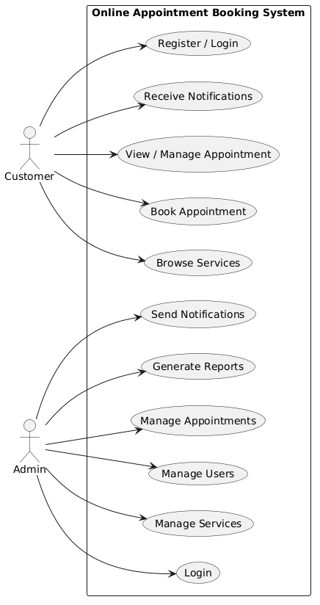

3.4 Classes / Objects
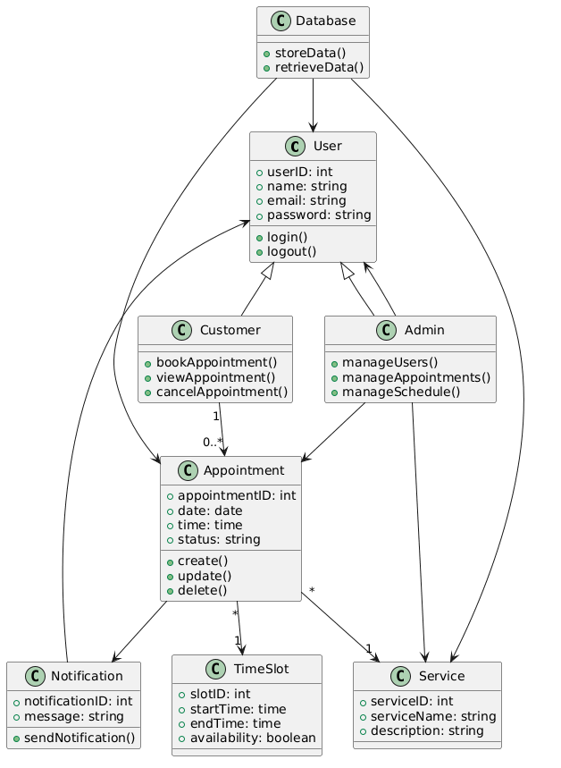

3.5 Non-Functional Requirements
Non-functional requirements define the system-wide characteristics that the Online Appoinment Booking System must satisfy. These requirements focus on quality attributes such as performance, reliability, usability, security, and maintainability.

3.5 Non-Functional Requirements

3.5.1 Performance
Our solution needs to process and complete user initiated actions such as booking an appointment within two seconds, updating details related to an existing appointment within two seconds, as well as processing and populating information on the system's dashboard within two seconds during normal system usage. The system will also need to process requests from many concurrent users at the same time.

3.5.2 Reliability
Correct processing and storage of appointment, user, and notification data is critical for this project. Should a server or network failure occur, the system will autonomously and automatically fail over to another location, without any adverse effects on user or administrator, maintaining integrity of all data.

3.5.3 Usability
Simple navigation, clear forms and layouts, effective dashboards and logical and clear notifications. Simple to use for both customers and administrators with little or no training needed to make a booking for a service or manage services. Feedback messages should help users avoid making mistakes and enhance their experience.

3.5.4 Security
Security is implemented on the website to protect both user information and system information. The website uses a secure login system with full support for authentication and authorisation, as well as data validation and encryption to help prevent unauthorised access to user information and appointment details.

3.7 Logical Database Requirements
Entity | Description | Key Attributes | Frequency of Use | Access Capabilities
User | Stores information about registered users of the system | userID, name, email, password, role, registrationDate | Medium (login, account updates, profile management) | Read/Write by admin; Read/Write by user for own account
Appointment | Stores details of appointments booked by users | appointmentID, userID, serviceID, date, time, status, specialInstructions | High (booking, updating, and cancellations) | Read/Write by user/admin; Read by reporting module
Service | Stores information about available services | serviceID, name, description, pricing, availability | Medium (browsing, selection, and updates) | Read by all users; Read/Write by admin
Notifications / Alerts | Stores messages sent to users for appointment reminders or system events | alertID, userID, appointmentID, timestamp, eventType, message | Medium (triggered for reminders or changes) | Write by system; Read by user/admin
System Configuration | Stores global or user-specific operational settings | configID, userID, preferences, thresholds, notificationSettings | Low (when settings are modified) | Read/Write by admin; Read by system
Analytics / Metrics | Aggregated data on system usage, bookings, and performance | metricID, userID, appointmentCount, cancellations, notificationsSent, timestamp | Medium/High (for dashboards and reports) | Write by system; Read by admin for monitoring

4. Analysis Models
Several analysis models have been developed to provide a clear understanding of the functional and non-functional requirements of the Online Appoinment Booking system and to support traceability throughout the SRS. These models include use case diagrams, class diagrams, sequence diagrams, entity-relationship (ER) diagrams, and state transition diagrams.
- The use case diagram identifies interactions between external actors, such as users, administrators, and external services (e.g., email, analytics APIs), with the system, providing a visual representation of all primary functionalities, including service browsing, campaign management, user management, reporting, notifications, and system configuration.
- The class diagram captures the static structure of the system, showing major classes such as SystemController, User, Campaign, ServiceManager, Analytics, NotificationManager, and Logger, along with their relationships. This allows developers to trace each class to the functional requirements it supports.
- Sequence diagrams illustrate the flow of operations for critical functions, such as creating campaigns, updating analytics, sending notifications, or generating reports, showing the order of interactions between classes and external entities.
- The ER diagram represents the logical data model, identifying data entities, attributes, and relationships for users, campaigns, services, metrics, and alerts, providing a foundation for database design and ensuring traceability to data storage and retrieval requirements.
- State transition diagrams model the dynamic behavior of key system components, such as campaign states (draft, active, completed) and notification sequences, ensuring all possible system states and transitions are accounted for in functional requirements.
Together, these analysis models form a comprehensive framework that supports the derivation, validation, and traceability of all requirements documented in this SRS, providing developers and stakeholders with a clear understanding of system behavior, interactions, and expected operations.

4.1 Sequence Diagrams
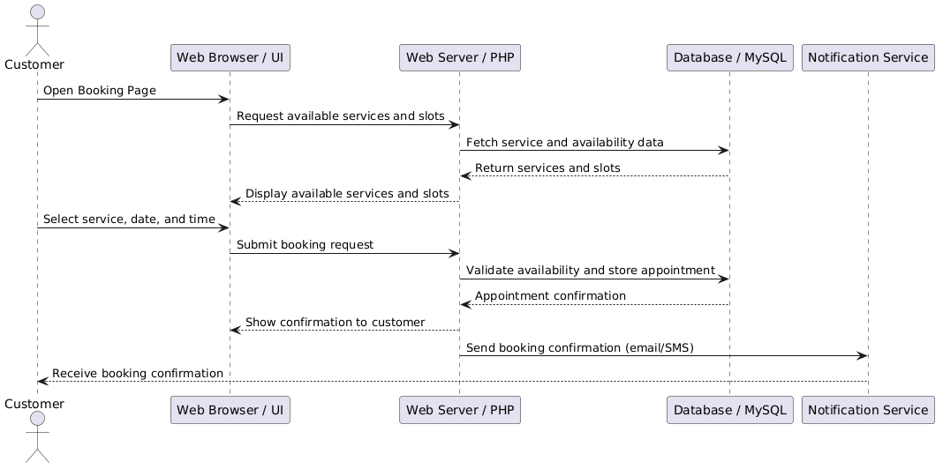

4.2 Data Flow Diagrams (DFD)

Level 0
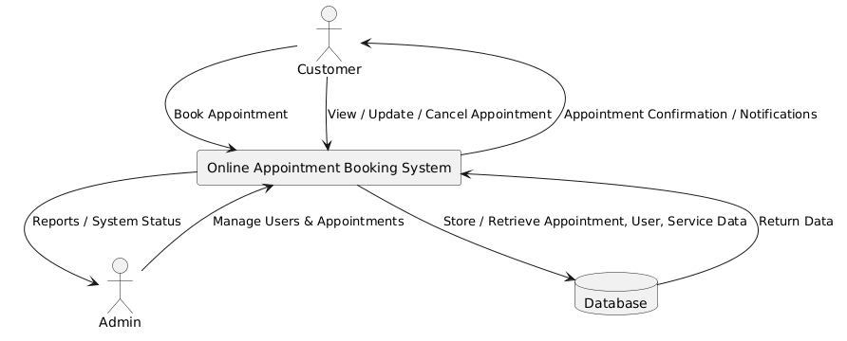

5. Supporting Information
Our Online Appointment Booking System is a web based platform that simplifies the process of scheduling, managing and tracking of online appointments for Service Providers, Clinics and Retail Outlets. With this system, users can make, cancel or change appointments online, check availability in real time and also view past appointments. All information, appointment details and system activity are stored in an organized database format to serve as valuable resource for business reporting and analysis. Optional notifications can be set up to send reminders, confirmations or alert users on any change to their appointments or system activity.
While features and user stories have been elaborated, the solution also prioritizes usability, reliability and maintainability enabling a person with little or no knowledge of the current solution to easily create and update dashboards, booking and associated services. Importantly the non-functional requirements of performance, security, data integrity and organisational standards have also been well defined. These need to be met by the solution to ensure consistent and reliable operation.
Supporting analysis models such as use case diagrams, class diagrams, sequence diagrams, ER diagrams, state transition diagrams allows to get a clear picture of system behavior, data flow and user interactions. Together with the specifications these models provide a thorough view of the system's functionality and serve as a sound basis for design, realization and testing.

